RESUME
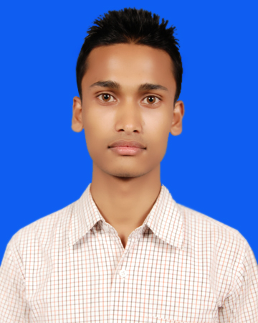
SHAH ALAM ISLAM
B.Tech (Electronics and Communication Engg)
Contact No: 9476713270/8522980977
Email ID: alamislamis@gmail.com
Present Address:
#73, Dewan Complex, Bhetapara Road
Hatigaon Chariali, Guwahati-781038

CAREER OBJECTIVE

To work in a firm with a professional work driven environment where I can utilize and apply my knowledge, skills, creativity and innovative thinking for benefit of the organization and me.

WORK EXPERIENCE

Company Name: Sellcraft Softech Pvt. Ltd.
Designation: IT Helpdesk Engineer (Work Location: TCS, Hyderabad)
Duration: 23rd May 2016 – 3rd Jan 2017

Job Responsibilities:
- Responsible for handling Inbound Calls, Outbound Calls and Emails.
- Responsible for taking Complaints, Feedback, Queries & Suggestions.
- To Analyze and summarize customer issues in order to get appropriate solutions from the concern person.
- Inform the solution to customer which is provided by the concern person.
- Address customers in a professional and respectful manner.
- Maintain up-to-date knowledge on customer business areas.
- Maintain broad knowledge about company’s products and services.
- Develop and implement initiatives to improve customer services.
- Tools Used: SAP CRM

ACADEMIC CREDENTIALS

QUALIFICATION | BOARD/UNIVERSITY | YEAR | PERCENTAGE | Division/  Class
B.Tech (ECE) | PTU, Jalandhar | 2011-2014 | 84.62% | 1st(Distinction)
Diploma (ETC Engg) | SCTE, Assam | 2011 | 73.37% | 1st(Honors)
HSLC | SEBA, Assam | 2008 | 69% | 1st div

INDUSTRIAL TRAINING AND PROJECT

- Complete six month industrial training at “RTTC, Guwahati” and worked on “Broadband communication, Optical fibre communication, Mobile communication, IP Networking & cyber security”.
- Complete six week industrial training at “PUNCOM (Punjab communication limited), Mohali” and worked on “Power Line Carrier Communication”.

PROJECT

- SMS Controlled Multipurpose I/O Module
- Cell Phone Operated Robot

COMPUTER SKILLS

- MS Office
- Internet Browsing
- Programming Language: C, C++
- Operating System: Windows XP/07/08

OTHER QUALIFICATION

- Certificate in “Programming in C” from NIIT, Jorhat
- Diploma in “Hardware Maintenance & Networking” from MICE, Jorhat
- Certificate in “FM Transmitter & Studio setup” from PRASAR BHARTI (All India Radio), Patiala

STRENGTHS

- Ability to work under Stress
- Ability to lead Team
- Hard Working
- Honest

INTERESTS

- Internet Surfing
- Travelling

PERSONAL DETAILS

- Date of Birth :- 28th April 1992
- Father’s Name :- Nurul Islam
- Permanent Address :- Vill+PO: Bagodi, Dist: Barpeta(Assam), PIN: 781311
- Language Known :- English, Hindi, Bengali & Assamese
- Hobbies :- Travelling, Listening Music & playing computer game
- Marital Status :- Single
- Gender :- Male
- Nationality :- Indian
- Blood Group :- B+

DECLARATION

I do hereby declare that the above information is true to the best of my knowledge.

Place: Guwahati
Date: (Shah Alam Islam)

